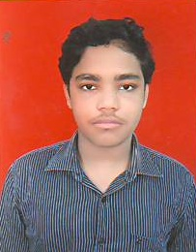
CURRICULUM VITAE
KRISHNA PARIDA
Kalinaga nagar,
Berhampur,Ganjam Contact No- 7790020732
Odisha EMAIL-kp27review@gmail.com

CAREER OBJECTIVE:
A self motivated ready to work challenging and any environment with opportunities to increasing my knowledge, experience and skill. Want be a successful person by putting my best efforts.
ACADEMIC QUALIFICATION:
- Diploma In Civil Engg. :Kalam institute of technology(poly),Berhampur,Ganjam
- HSC From : Saraswati Sishu Vidya Mandir,Gajapati Nagar,Berhampur,Ganjam
- AUTOCAD (UNISOFT COMPUTER TRAINING INSTITUTE), Berhampur,Ganjam
STRENGTH
- Creating ideas: creativity
- Self Motivated
- Leadership & Responsible
HOBBIES
- Running
- Charity
PERSONAL DETAILS
Name : Krishna Parida
Father’s Name : Kedar Nath Parida
Date of Birth : 27th Jan 1997
Sex : Male
Marrital Status : Unmarried
Laguage Knows : English, Hindi, Odia
Nationality : Indian
Place: - Bhubaneswar
Date - 01/03/2016 (student signature)

